**Section 2: Quiz 1:**

**Quiz: Mean:** Question 1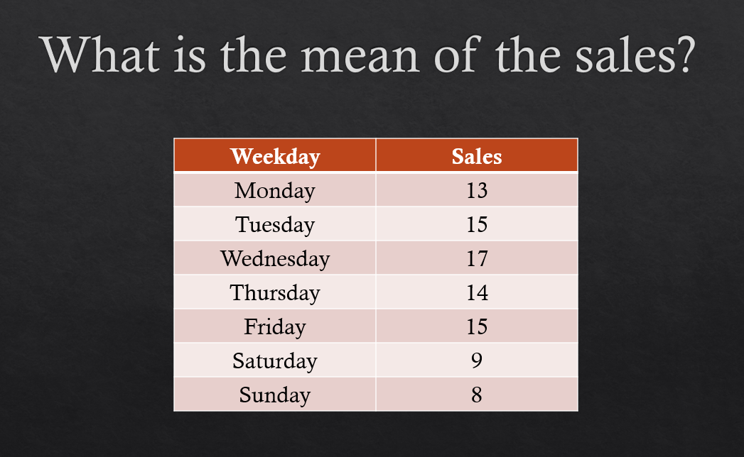

* **13**
* **14**
* **15**
* **16**

**Answer: 13** (13+15+17+14+15+9+8) / 7 = 13

**Section 2: Quiz 2:**

**Quiz: Median**: Question 1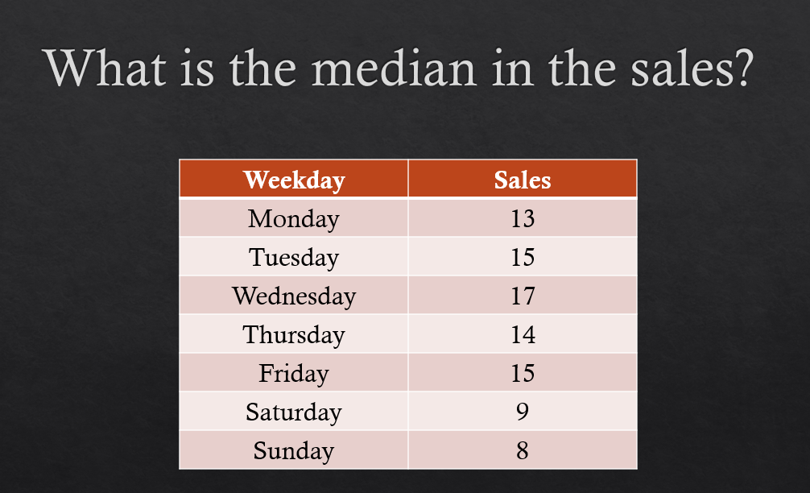

* **13**
* **14**
* **15**
* **16**

**Answer: 15** (Sort the values and select the one in the middle: 8-9-13-14-15-15-17)

**Section 2:**

**Quiz 3: Quiz: Mode**: Question 1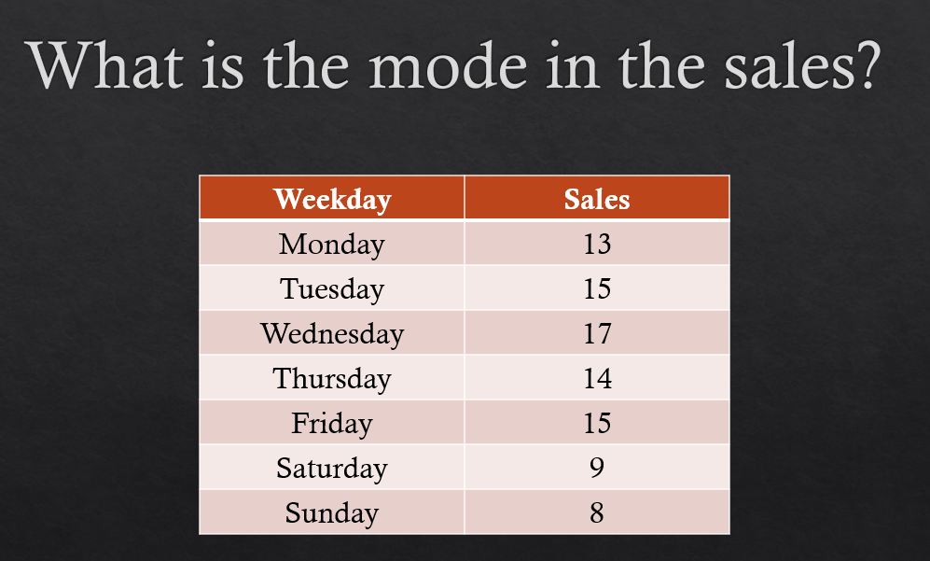

* **13**
* **14**
* **15**
* **16**

Answer: 15 (since this is the most frequent number)

**Section 2: Quiz 4:**

**Quiz: Variance**: Question 1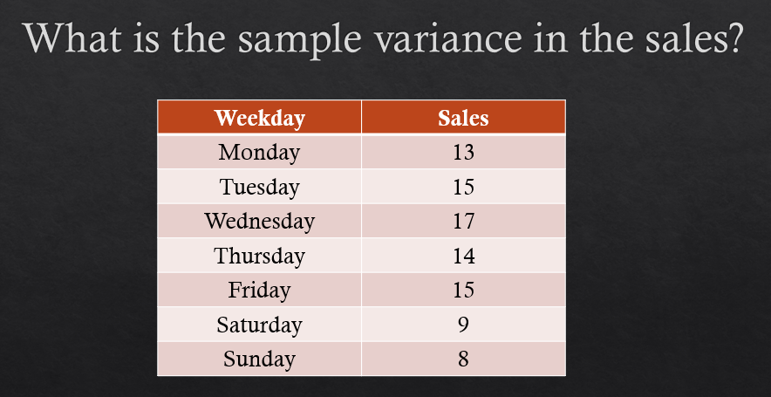

* **10**
* **9.5**
* **11**
* **12.5**

**Answer: 11**

**Section 3: Quiz 5:**

**Normal distribution**: Question 1:

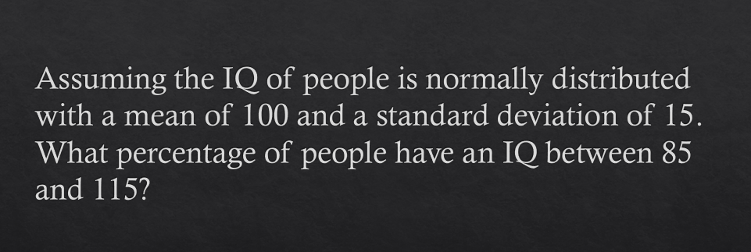

* **About 95%**
* **About 68%**
* **About 50%**
* **About 97%**

**Answer: About 68%** (According to the empirical rule there is 68% of the data within one standard deviation)

Question 2:

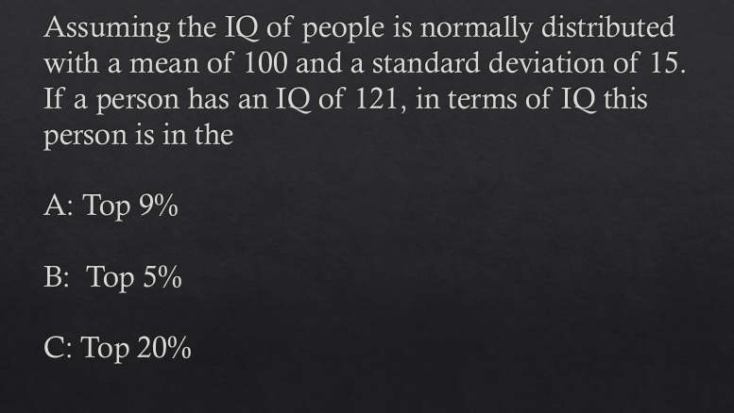

* **A**
* **B**
* **C**

**Answer: Top 9%**

**Section 4: Quiz 6:**

**Quiz: Bayes Theorem**: Question 1:

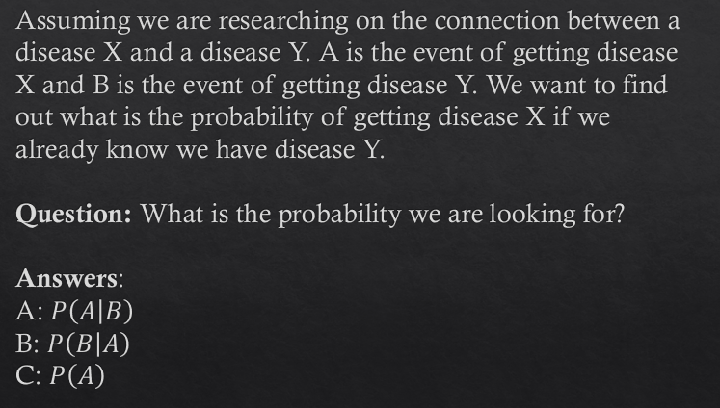

* **A**
* **B**
* **C**

**Answer: A**

Question 2:

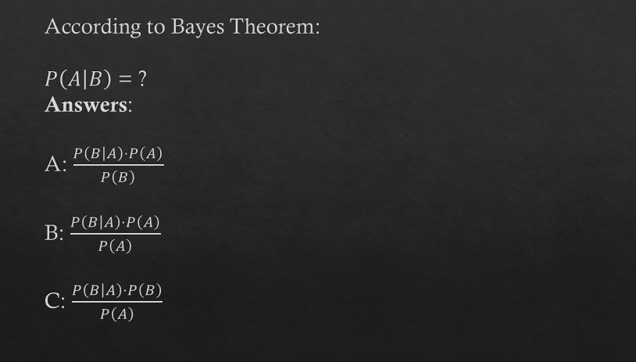

* **A**
* **B**
* **C**

**Answer: A**

Question 3:

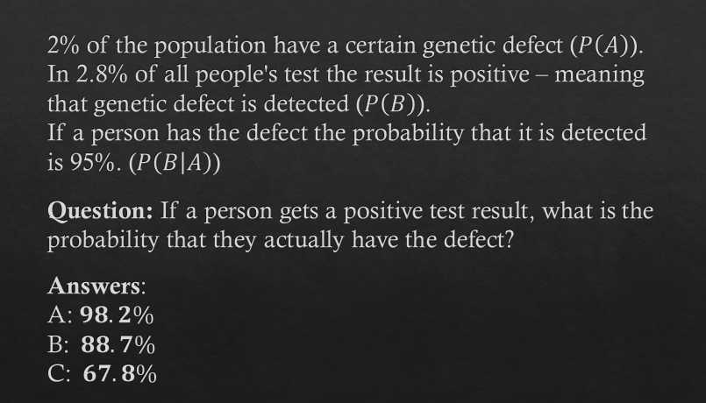

* **A**
* **B**
* **C**

**Answer: C**

**Section 5: Quiz 7:**

**Quiz: Hypothesis Testing**: Question 1:

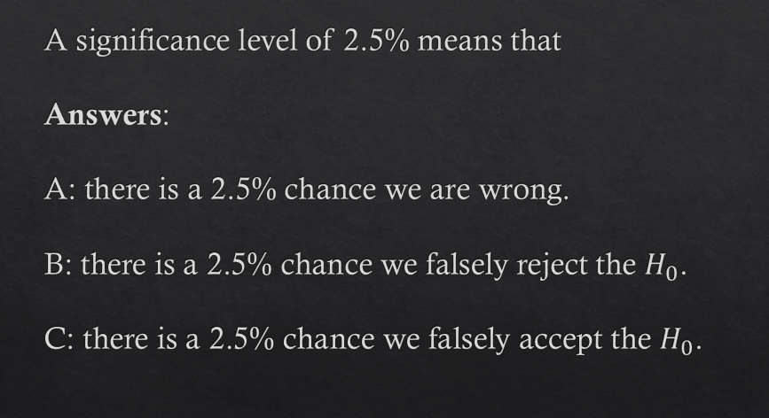

* **A**
* **B**
* **C**

**Answer: B**

Question 2:

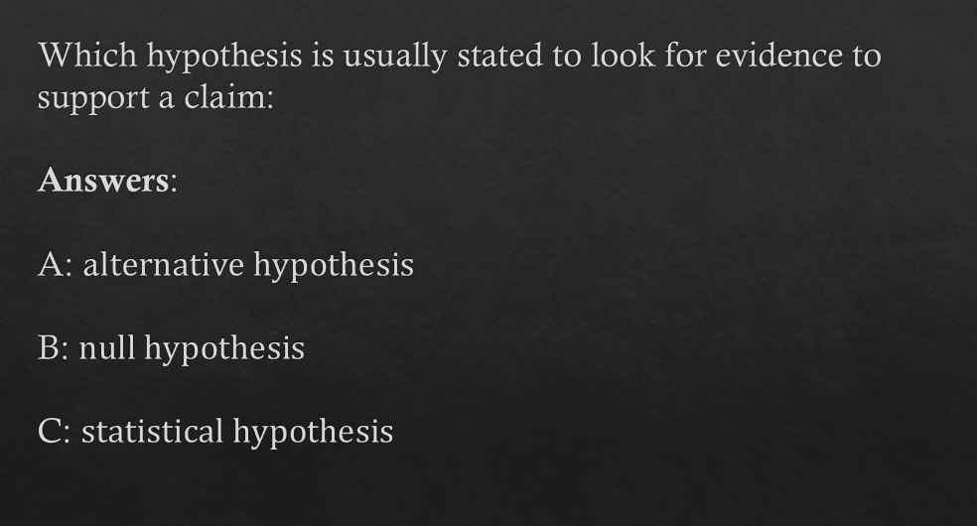

* **A**
* **B**
* **C**

**Answer: A**

Question 3:

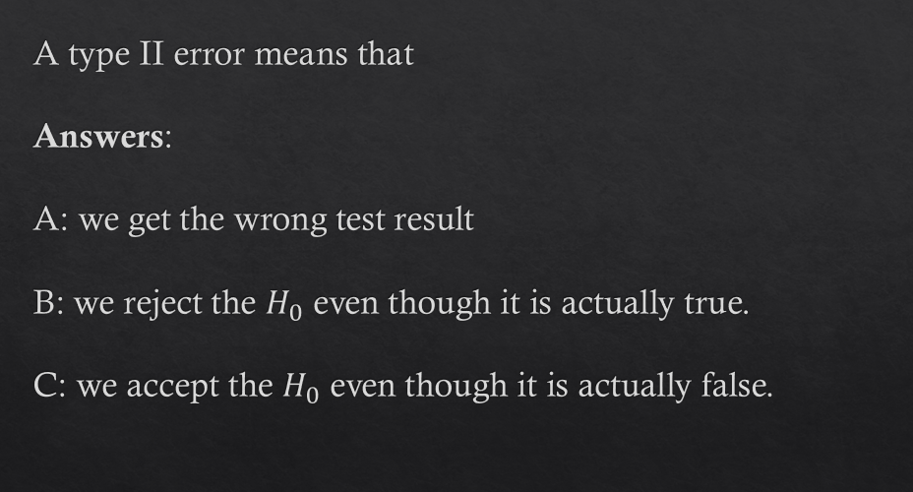

* **A**
* **B**
* **C**

**Answer: C**

**Section 6: Quiz 8:**

**Quiz: Regression**: Question 1:

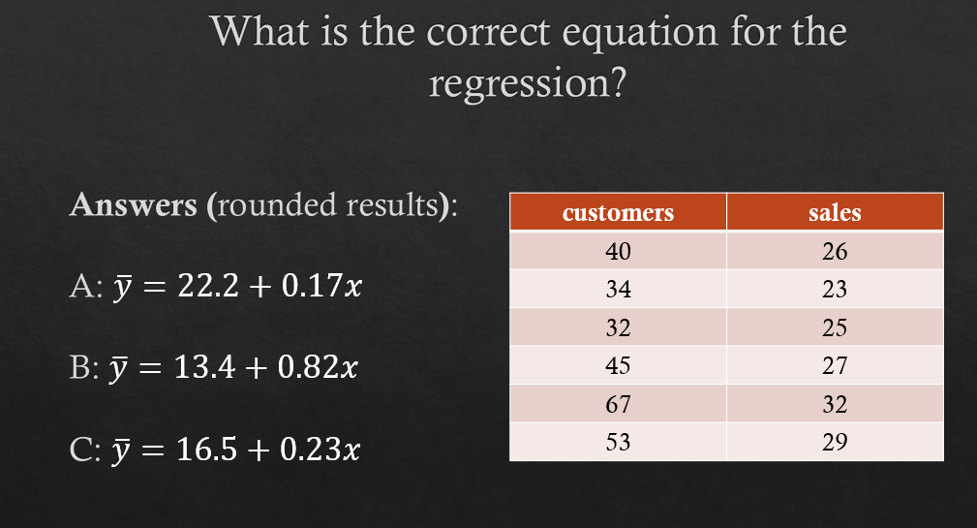

* **A**
* **B**
* **C**

**Answer: C**

**Section 8: Quiz 9:**

**Quiz: ANOVA**: Question 1:

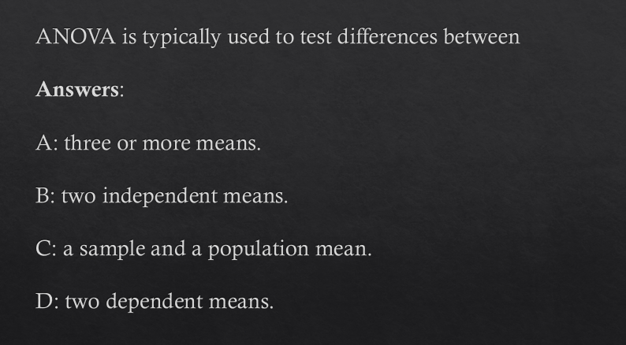

* **A**
* **B**
* **C**

**Answer: A**